LIONEL POPKIN

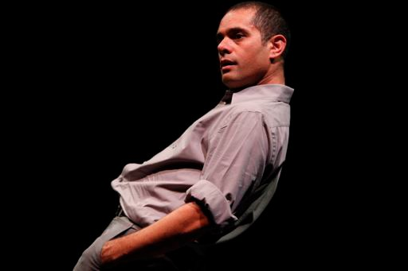
photo by Steven Gunther

PRESS KIT CONTENTS:

• ARTIST BIO
• CURRENT REPERTORY
• PRESS PHOTOS
• QUOTES

ARTIST BIO

Lionel Popkin is a choreographer/performer who sees the world as hybridized over homogenized, gloriously confusing instead of needing fusion, and who consistently values bodily experience as the primary way we orient to our world. During the decade from 2004-2013 he made works looking at the cross-cultural conversation between his post-modern training and the imagery and iconography of the Indian subcontinent that surrounded his youth. His recent work has focused on the more intimate familial world, questioning conceptions of home from the point of view of the itinerant, the domesticated and the mobilized.
He tours and performs his projects throughout the United States, where he is based, and abroad. He has had his choreography presented nationally and internationally at numerous venues including Danspace Project Abrons Arts Center and Dance Theater Workshop in New York City, The Getty Museum and REDCAT in Los Angeles, the Jacob's Pillow Inside/Out Series, The Painted Bride and Philadelphia Dance Projects in Philadelphia, ODC in San Francisco, The Place Theater in London, and the Guongdong Modern Dance Festival in Guongzhou, China.
From 1999–2000 Lionel was a Choreographer-In-Residence at the Susan Hess Studio in Philadelphia, PA and he has been commissioned by San Diego's Lower Left Performance Collective, the Li Chiao-Ping Dance Company, Carolyn Hall, and Nejla Yatkin. As a dancer, Lionel has performed throughout the US and Europe in the companies of Trisha Brown, Terry Creach, and Stephanie Skura.
He has received grants from the National Performance Network's Creation Fund, the National Dance Project Touring Subsidy, the Center for Cultural Innovation, the Puffin Foundation, the Doris Duke Charitable Foundation, and the Durfee Foundation. He has served on the faculty of Bates College, London's Laban Centre, Sarah Lawrence College, Temple University and the University of Maryland.
Lionel Popkin is the Chair of the Department of World Arts and Cultures/Dance at UCLA, and Professor of Choreography and Performance. He is a certified teacher of Skinner Releasing Technique.

CURRENT REPERTORY

INFLATABLE TRIO (2017)
Performed on, and around, an inflatable plastic living room set, Inflatable Trio questions the ways we attempt to orient ourselves within ever-changing domestic, social and environmental landscapes. As the elements of a family room are repeatedly deflated, dismantled and re-organized, three dancers poignantly persist, react and cope. Each in turn upends—and is upended by—the objects, people and situations that surround them.

Inflatable Trio emerges as a kind of domestic drama, expanded beyond its walls, where the current state of our capacities to navigate one another resonates with our shifting global and environmental challenges. Increasingly we communicate without our bodies present (war without our bodies present)—has this heightened the impact of the physical exchange? What does domestic interaction mean in this context? Is home a retreat, a seductive space where we still touch and confront one another? Are we equally equipped for the encounter?

CREATIVE TEAM
Choreography: Lionel Popkin Original Score: Tom Lopez
Performed by: Carolyn Hall, Lionel Popkin, Samantha Mohr, with Tom Lopez
Video Design: Cari Ann Shim Sham
Costumes: Maria Garcia

PERFORMANCE HISTORY of Inflatable Trio
Skirball Cultural Center, Los Angeles, CA
Wilson Center, Wilington, NC
Oberlin College, Oberlin, OH
Tongva Park, Santa Monica, CA

AWKWARDLY RELATED: ON THE ROAD WITH OEDIPUS AND ANTIGONE (forthcoming in 2019)
Awkwardly Related: On the Road with Oedipus and Antigone examines the time that passes in-between two classic Sophocles plays: “Oedipus the King” and “Oedipus at Colonus.” It follows the journey Oedipus and Antigone undertake as father/daughter, brother/sister, traveling as societal outcasts at the end of one play to oddly empowered individuals at the beginning of the next. Instead of recreating Sophocles’ time, I am asking what the story of these exiles reveals about conflicting allegiances between family loyalties and contemporary citizenship in today’s political climate. The piece premieres in Los Angeles at the Getty Villa’s Theater Lab Series in February 2019 and tours in 2019-20.
PRESS PHOTOS

Inflatable Trio, photo by Isaac Obaka
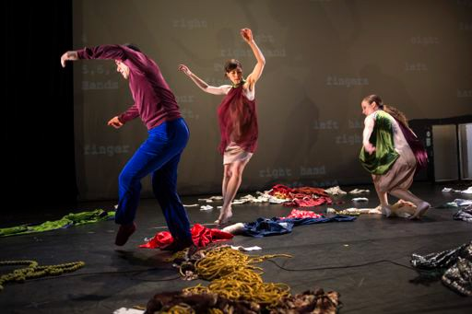

Ruth Doesn’t Live Here Anymore, photo by Steven Gunther

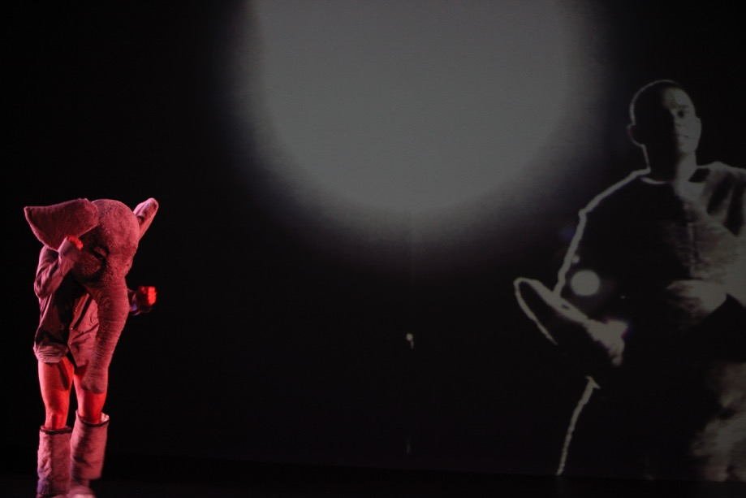
There Is An Elephant In This Dance, photo by Steven Gunther

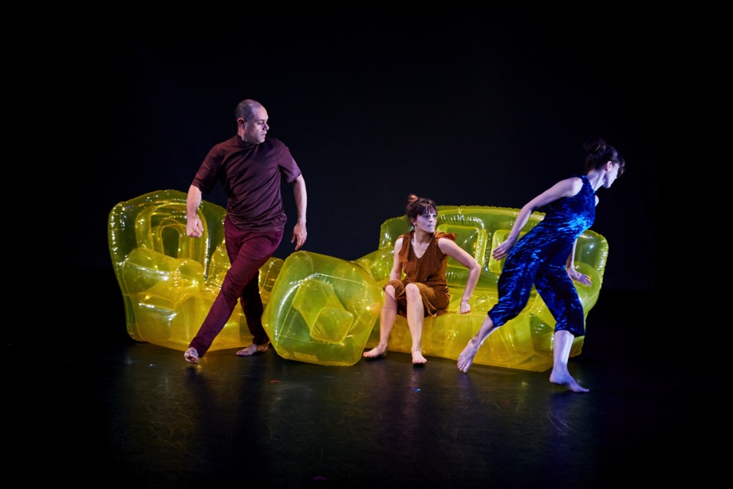
Inflatable Trio, photo by Isaaac Obaka

QUOTES

INFLATABLE TRIO
"Planted on sofas across America, many of us cower in abject terror of the nightly news. In a witty transformation, Popkin converts this inert set-up into something dynamic."
—Debora Levine, Arts Meme

"Sublime trios with the performers moving sensually as a unified whole, especially towards the work’s end, when their arms were wrapped, octopus-like, around one another’s shoulders, an especially poignant tableau"
—Victoria Looseleaf, Fjord Review

RUT H D OE SN ’ T L I V E HER E A N Y MO R E
“as farcical as it is dead serious”
–Siobhan Burke, The New York Times

“Inordinately engaging...[Ruth] was sprinkled with jewels of movement sequences, striking visuals and thought-provoking moments.”
–Pamela Squires, The Washington Post

“Popkin has a flair for originality that periodically has you realizing that you are smiling to yourself in the dark.”
–Pamela Squires, The Washington Post

THER E IS A N EL EP HA NT IN THIS DA NC E
“By turns comical, creepy, and uncanny... The whole dance is like that: disquieting, the cliché pushed past the literal.”
–Brian Siebert, The New Yorker

“I can urge you to go see this delectable, dreamy, poetic, luminous thing!”
–Eva Yaa Asantewaa, InfiniteBody

“Popkin eloquently demonstrates that the truth is something of our creation, informed by who we are and who we will become.”
–Carolina Palmer, Minneapolis Star Tribune

AND T HEN WE EAT
“Strong, pliant and full of body-upon-body maneuvers... a metaphor for more intimate adventures.”
–Tobi Tobias, The Village Voice

“Scrumptious... a sensuous, sizzling duet.”
–Kris Eitland, San Diego Theater Scene

OTHER WORKS
“One of the most satisfying premieres... heightened and transformed one’s perception of the theatrical space.”
–Sara Wolf, Dance Magazine

